Bug Report - 04:

Admin Panel UI overlaps with other buttons
Environment: Windows 11, Opera GX
Test Object: Admin Panel UI

Preconditions:
- The website is open at the login screen

Steps:
- Click on the 'Admin Panel' button at the bottom right
- Observe the bottom area of the opened modal

Expected Result:
- The modal should appear on top with a background overlay covering all background buttons

Actual Result:
- Background buttons like 'No cash', 'help', and the blue bar overlap and appear above the modal's content
Attachment:
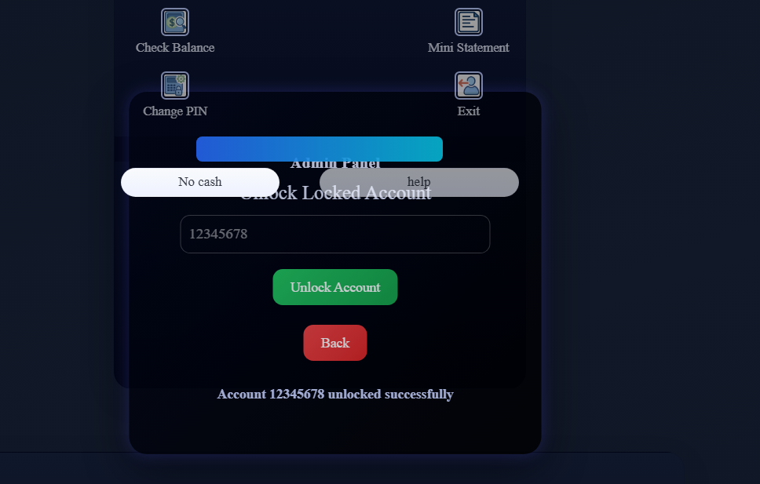
Severity: Medium
Priority: Low

